

**Project Proposal Report**

**Kingfisher Hotel Management System**

Group: Redliners

ID: G08

Client Name: J.B. Sehan Madhuka

Version 1.0

Date: 02/13/2025

This proposal is submitted to the Information Technology department in partial fulfillment for the PPA module in the Diploma in Information Technology program.

# DECLARATION

We hereby declare that the project work entitled “Kingfisher Hotel Management System”, submitted to the SLIIT City Uni (Pvt.) Ltd. a subsidiary of Sri Lanka Institute of Information Technology is a record of an original work done by us, under the guidance of our Supervisor “Name of the supervisor”. This project work is submitted in the partial fulfillment of the requirement for the award of the Diploma in Information Technology. The Results embodied in this report have not been submitted to any other University or Institution for the award of any degree or diploma. Information derived from the published or unpublished work of others has been acknowledged in the text and a list of references is given.

**Project ID: G08**

**Group Members: 6**

|  |  |  |
| --- | --- | --- |
| **Student ID** | **Student Name** | **Signature** |
| **SA23089754** | **A.A. Rifath** |  |
| **SA23428324** | **H.G.S. Sanchitha** |  |
| **SA23442016** | **M.M.N.S. Bandara** |  |
| **SA23438538** | **E.T. Rusiru** |  |
| **SA23439450** | **H.K. Dilanjan** |  |
| **SA23514522** | **P.M.C.R. Bandara** |  |

**Date of Submission:** 02/13/2025

|  |  |
| --- | --- |
| Supervisor | Client |
| Name : | Name : J.B. Sehan Madhuka |
| Signature : | Signature : |

Table of Contents

DECLARATION i

LIST OF TABLES iv

LIST OF FIGURES iv

1 INTRODUCTION 1

1.1 BACKGROUND OF THE CLIENT/ PROJECT 1

1.2 PROBLEM STATEMENT 1

1.3 NEEDS STATEMENT 1

1.4 SOLUTION AND OBJECTIVES 1

2 PROPOSED TECHNICAL APPROACH 2

2.1 DEVELOPMENT METHODOLOGY 2

2.2 REQUIREMENT GATHERING 2

2.3 ARCHITECTURE DIAGRAM 3

2.3.1 AS IS SYSTEM 3

2.3.2 TO BE SYSTEM 3

2.4 FUNCTIONAL REQUIREMENTS 4

2.5 NON-FUNCTIONAL REQUIREMENTS 4

2.6 IMPLEMENTATION AND DEVELOPMENT REQUIREMENTS. 4

2.7 RUNNING ENVIRONMENT REQUIREMENTS 4

2.8 QUALITY ASSURANCE PLAN 4

3 EXPECTED PROJECT RESULTS 5

3.1 DELIVERABLES 5

3.2 MEASURES OF SUCCESS 5

4 BUDGET 6

5 ROLES AND RESPONSIBILITIES 7

6 SCHEDULE 8

7 REFERENCES 9

8 APPENDICES 10

# LIST OF TABLES

Table 3.2.1: Roles and responsibilities of the project. 7

# LIST OF FIGURES

Figure 2.1.1: Waterfall development methodology 2

Figure 2.3.1: AS IS System 3

Figure 2.3.2: TO - BE System 3

Figure 2.4: user case diagram………………………………………………………….7

Figure 5: The Gantt Chart …………………………………………………………...17

# INTRODUCTION

A premier hospitality location, Kingfisher Beach Resort is committed to giving visitors outstanding experiences. The resort intends to install a thorough hotel management system in order to increase operational effectiveness and service delivery. Essential procedures including staff scheduling, inventory monitoring, customer record management, payment processing, and accommodation reservations will all be streamlined by this system. The resort hopes to improve overall visitor satisfaction, minimize mistakes, and optimize resource allocation by substituting an automated solution for manual techniques.

## BACKGROUND OF THE CLIENT/ PROJECT

Mr. J.B. Sehan Madhuka owns the acclaimed hospitality company Kingfisher Beach Resort. Having worked in the field for many years, he has established a solid reputation for providing guests with exceptional services and an unforgettable stay. Nevertheless, the resort still uses manual procedures, which results in ineffective management of staff schedules, bookings, customer data, payments, and inventories. The goal of this project is to create a fully working hotel management system that will automate and simplify everyday activities in order to overcome these obstacles.

**Business Operations:**  
Serving both domestic and foreign visitors, Kingfisher Beach Resort offers first class lodging and hospitality services. Keeping an ideal supply inventory, handling reservations, and providing flawless guest experiences are all part of the resort's operations. It also manages personnel scheduling and client payments, both of which need a contemporary system to increase accuracy and efficiency. The resort will be able to maximize resource use, reduce mistakes, and enhance overall service quality by putting this approach into practice.

## PROBLEM STATEMENT

Currently, Kingfisher Beach Resort manages its daily operations using a manual approach, which results in a number of inefficiencies. Inaccurate tracking of room availability, delayed reservation processing, and payment handling mistakes are all consequences of the absence of automation. Additionally, there is a greater chance of errors and delays when staff scheduling, inventory, and customer information are managed manually. These inefficiencies restrict the resort's capacity to deliver a smooth and effective service, lower client happiness, and impact overall productivity.

## NEEDS STATEMENT

To effectively manage reservations, client information, payments, inventory, and employee scheduling, Kingfisher Beach Resort needs an integrated hotel management system. In order to improve decision making, the suggested system should automate these procedures, reduce human error, and offer real-time insights. The resort may increase operational effectiveness, boost visitor pleasure, and guarantee smooth resource management by putting this idea into practice.

## SOLUTION AND OBJECTIVES

The proposed solution is to develop a hotel management system that will automate key operational processes at Kingfisher Beach Resort. This system will enhance efficiency, reduce errors, and improve overall service.

**The main objectives are:**

* To manage room reservations, cancellations, and availability more efficiently.
* To manage customer records efficiently for better service delivery.
* To streamline secure payment processing and transactions.
* To optimize inventory management for hotel supplies and amenities.
* To improve employee scheduling and workload distribution.
* To generate real-time reports for informed decision making.

# PROPOSED TECHNICAL APPROACH

## DEVELOPMENT METHODOLOGY

For the development of the Kingfisher Beach Resort Hotel Management System, we have chosen the Waterfall Development Methodology. This methodology is well-suited for this project due to its structured and sequential approach, which ensures that each phase of the project is completed before moving on to the next. The Waterfall model consists of distinct phases: Requirements Gathering, System Design, Implementation, Testing, and Deployment.

The primary reason for selecting the Waterfall methodology is the clear and linear progression it offers, which is ideal for a project with well-defined requirements and a fixed timeline of 8 weeks. Since the requirements for the hotel management system are already well understood, the Waterfall model allows us to focus on completing each phase thoroughly before proceeding to the next, minimizing the risk of scope creep and ensuring that the project stays on track.

Additionally, the Waterfall model provides a clear documentation trail, which is beneficial for both the development team and the client. Each phase produces deliverables that can be reviewed and approved before moving forward, ensuring that the final product meets the client's expectations [1].

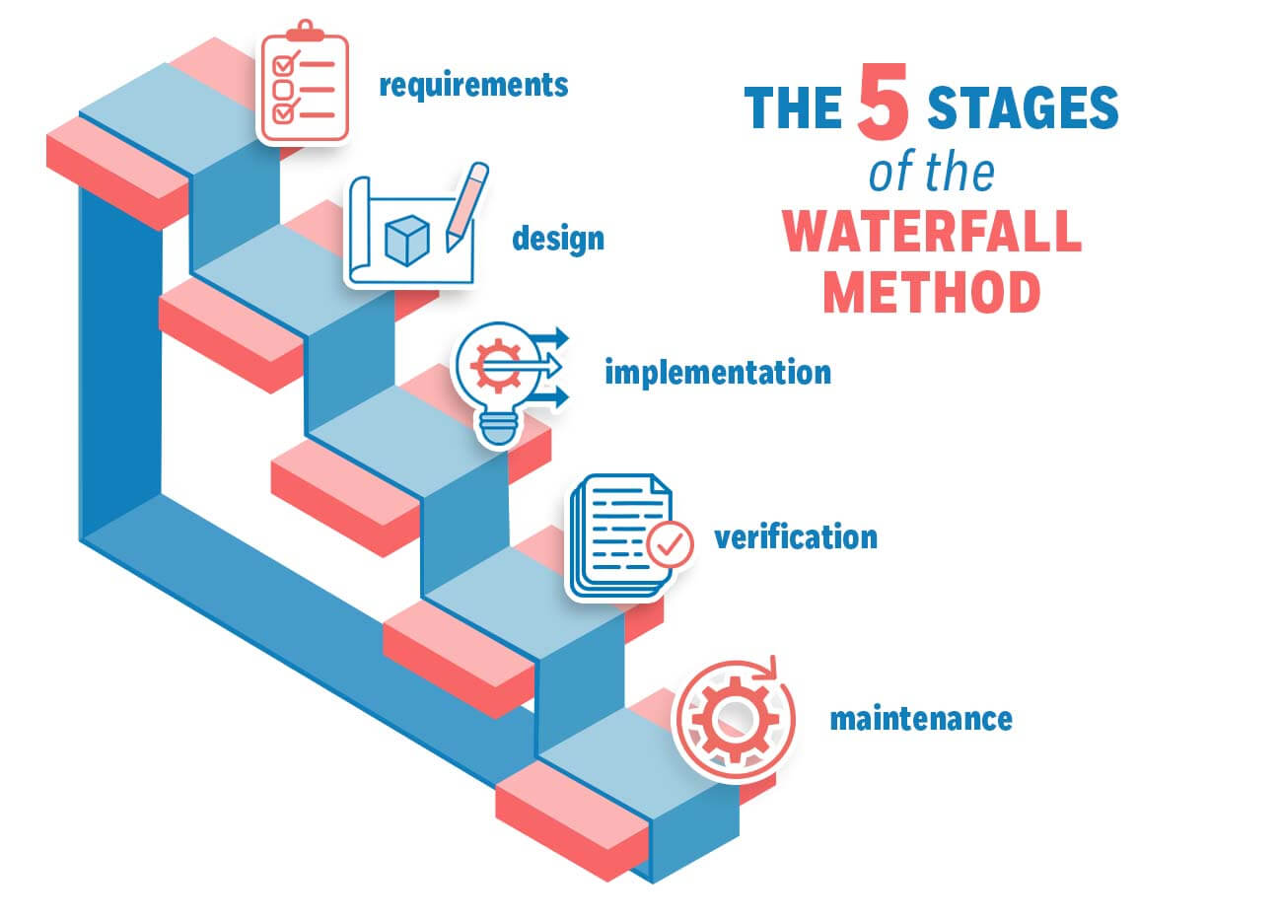

Figure : Waterfall development methodology [2]

## REQUIREMENT GATHERING

The requirement-gathering process was conducted through a combination of interviews and questionnaires with the hotel staff and the client. These methods were chosen to ensure that we captured both the technical and operational needs of the resort.

**Interviews:** We conducted one-on-one interviews with key stakeholders, including the hotel manager, front desk staff, and inventory managers. These interviews helped us understand the pain points in the current system, such as manual room booking processes, inefficient payment handling, and challenges in inventory management.

**Questionnaires:** We distributed questionnaires to a broader group of staff members to gather additional insights into their daily workflows and identify areas where automation could improve efficiency.

The data collected from these methods were analyzed and used to define the functional and non-functional requirements of the system. The findings were documented and shared with the client for validation before proceeding to the design phase [3].

## ARCHITECTURE DIAGRAM

The system architecture is designed to transition from the current AS-IS system to the proposed TO-BE system. The architecture diagrams provide a visual representation of how the new system will improve upon the existing processes.

### **AS IS SYSTEM**

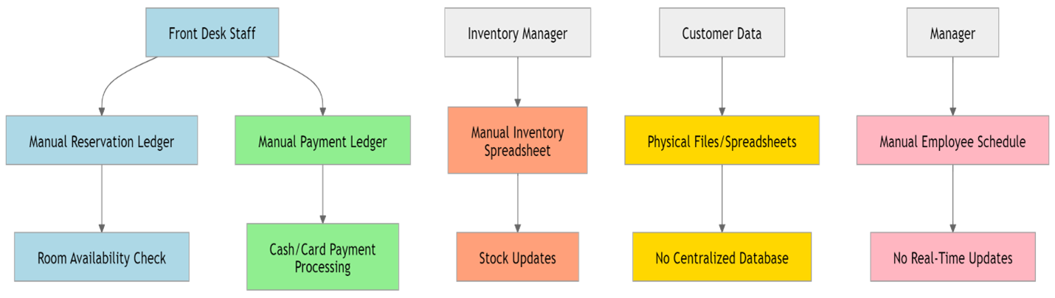

Figure .: AS IS System

### **TO BE SYSTEM**

The proposed system will introduce automation and real-time updates to streamline operations. Key features include automated room booking, secure internal payment processing, and inventory management. The TO-BE system will also include a centralized database for customer and employee management, as well as reporting tools for better decision-making. Importantly, the system is designed as an internal system with no online interaction with users. Only the receptionist and manager will have access to the system for managing reservations, payments, and other operations.

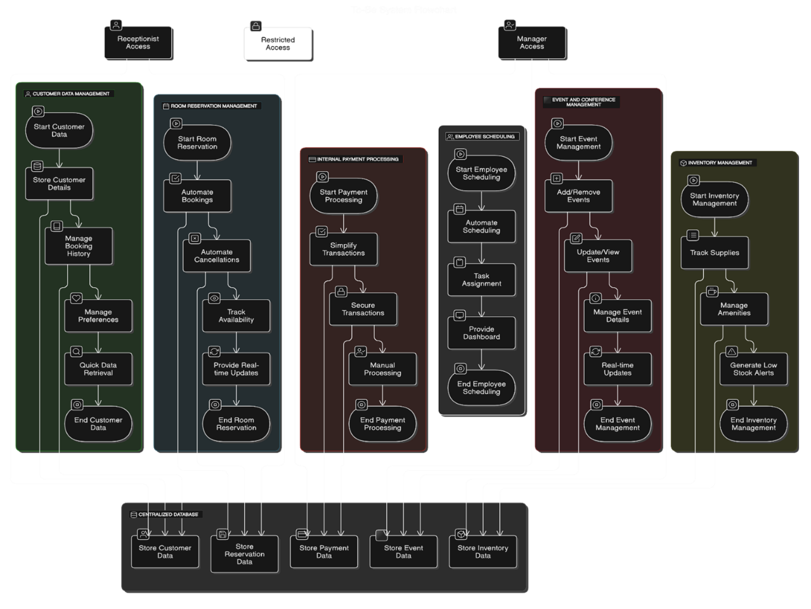

Figure .: TO - BE System

## FUNCTIONAL REQUIREMENTS

The functional requirements of the system are based on the needs identified during the requirement gathering phase. These requirements are categorized as follows:

**Room Reservation Management:**

* Automate room bookings, cancellations, and availability tracking.
* Provide real-time updates on room availability to prevent overbookings.

**Customer Data Management:**

* Store and manage customer details, including personal information, booking history, and preferences.
* Enable quick retrieval of customer data to enhance service quality.

**Internal Payment Processing:**

* Simplify and secure internal payment transactions for room bookings and additional services.

**Inventory Management:**

* Track and manage hotel supplies and amenities in real-time.
* Generate alerts for low stock levels to prevent shortages.

**Employee Scheduling:**

* Automate employee scheduling and task assignment.
* Provide a dashboard for employees to view their schedules and tasks.

**Event and Conference Management:**

* + Add, remove, update, and view events and conferences hosted at the resort.
  + Manage event details such as date, time, location, attendees, and resources required.
  + Provide real-time updates on event availability and conflicts.

**Reporting:**

* + Generate detailed reports on bookings, inventory, revenue, customer data, and event management.
  + Provide insights to support better decision making for the hotel management.

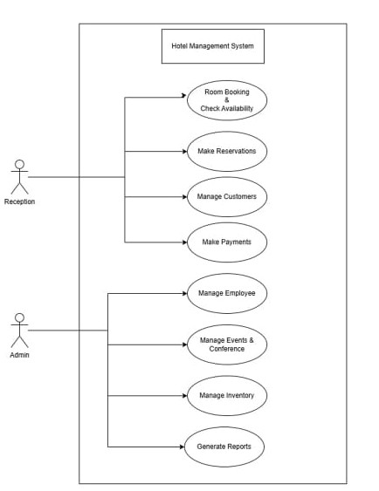

Figure 2.4: User case diagram

## **NON-FUNCTIONAL REQUIREMENTS**

**Usability:**

* + The system should have a user friendly interface that is easy to navigate for the staff.
  + Provide clear instructions and tooltips to guide users.

**Performance:**

* + The system should handle multiple users and transactions simultaneously without delays.
  + Ensure fast response times for all operations, especially during peak booking periods.

**Security:**

* + Implement secure authentication methods to restrict access to only authorized personnel.

**Scalability:**

* + The system should be scalable to accommodate future growth, such as an increase in the number of rooms or additional hotel branches.
  + Ensure that the database and server infrastructure can handle increased loads.

## IMPLEMENTATION AND DEVELOPMENT REQUIREMENTS.

The system will be developed using the following technologies:

* + Backend: Java (for business logic and server-side operations)
  + Database: MySQL (for storing customer data, bookings, and inventory details)
  + Frontend: JavaFX (for designing a user-friendly interface)

The development process will follow best practices such as modular programming, code reviews, and version control using Git. The system will be designed to be modular, allowing for easy updates and maintenance in the future.

## RUNNING ENVIRONMENT REQUIREMENTS

* + Operating System: Windows
  + Database: MySQL
  + Java Runtime Environment (JRE): Version 8 or higher
  + Hardware: Minimum 4GB RAM, 2GHz processor, and 500GB storage

## QUALITY ASSURANCE PLAN

To ensure the quality of the system, we will implement the following testing strategies:

* + Unit Testing: Test individual components of the system to ensure they function as expected.
  + Integration Testing: Verify that all components work together seamlessly.
  + User Acceptance Testing: Conduct testing with the hotel staff to ensure the system meets their needs.

A risk management plan will be in place to address potential issues such as delays in development, technical challenges, or changes in requirements. Regular progress reviews will be conducted to ensure the project stays on track.

# **EXPECTED PROJECT RESULTS**

The expected outcome of this project is a fully functional hotel management system designed to meet the specific needs of Kingfisher Beach Resort. The system will automate key operations, improve efficiency, and provide real-time insights for better decision-making. By streamlining reservations, payment processing, inventory management, and staff scheduling, the resort will experience enhanced operational capacity and improved guest satisfaction.

## DELIVERABLES

The main deliverables of the project include:

1. **Reservation and Booking System:**
   * A module to handle room reservations, cancellations, and availability tracking.
2. **Customer Management System:**
   * A centralized database for storing and managing customer details.
3. **Payment and Financial Management System:**
   * Secure payment processing and transactions.
   * Financial reporting for revenue, expenses, and outstanding balances.
4. **Inventory Management System:**
   * Tracking hotel supplies, amenities, and stock levels.
   * Alerts for low stocks via email notification to the client.
5. **Employee Scheduling and Management System:**
   * Staff scheduling and shift management.
6. **Report Generation:**
   * Real-time dashboards for monitoring key performance metrics.
   * Reports on transactions, inventory, bookings, etc and operational efficiency.
7. **Quality Assurance:**
   * Comprehensive testing, including unit testing, integration testing, and user acceptance testing.
8. **Event and Conference Management:**
   * Efficient management of events and conferences hosted at the resort.
9. **Database Management:** 
   * Efficient storage and management of customer data, booking records, and event details.
10. **Final Presentation:**
    * A formal presentation summarizing project outcomes, methodologies, and system features.

## **MEASURES OF SUCCESS**

The success of the project will be measured using the following metrics:

* + Reduction in Overbookings: Real-time room availability tracking will reduce overbookings by 90%.
  + Improved Customer Satisfaction: Efficient customer data management will increase customer satisfaction ratings by 20%.
  + Faster Internal Payment Processing: Simplified internal payment processing will reduce transaction times by 50%.
  + Better Inventory Management: Optimized inventory management will reduce stock shortages by 80%.
  + Efficient Event Management: Streamlined event and conference management will reduce scheduling conflicts by 70%.
  + Efficient Employee Scheduling: Scheduling will improve workload distribution, reducing employee overtime by 30%.

# BUDGET

## SOFTWARE DEVELOPMENT COST

The software development costs are based on the Waterfall Development Methodology, which includes distinct phases such as Requirements Gathering, System Design, Implementation, Testing, and Deployment. The estimated costs for each phase are as follows:

|  |  |  |  |  |
| --- | --- | --- | --- | --- |
| **Phase** | **Description** | **Estimated Hours** | **Hourly Rate**  **(Rs)** | **Cost**  **(Rs)** |
| **Requirements Gathering** | Conducting interviews, questionnaires, and analysis to define system requirements. | 10 | 200 | 2000 |
| **System Design** | Designing the system architecture, database schema, and user interface. | 25 | 200 | 5000 |
| **Implementation** | Coding the backend, frontend, and database. | 120 | 250 | 30,000 |
| **Testing** | Unit testing, integration testing, and user acceptance testing. | 30 | 200 | 6000 |
| **Deployment** | Training staff. | 40 | 300 | 12,000 |
| **Project Management** | Overseeing the project, ensuring timelines, and managing risks. | From start to finish | As a fix cost | 5000 |
| **Total Software Costs** |  |  |  | **Rs. 60,000.00** |

## **HARDWARE AND INSTALLATION COST**

The hardware and installation costs are based on the Running Environment Requirements outlined in the proposal. The following hardware and software are required to run the system

The client already has the computers, computer accessories, and networking devices required for the system, so there is no need to purchase new ones.

|  |  |  |  |  |
| --- | --- | --- | --- | --- |
| **Item** | **Description** | **Quantity** | **Unit Cost (Rs)** | **Total Cost (Rs)** |
| **Database License** | MySQL database license | 1 | 4000 | 4000 |
| **Installation and Setup** | Labor costs for installing hardware, configuring the network, and setting up the system. | 20 hours | **Rs. 300/hour** | 6000 |
| **Total Hardware Costs** |  |  |  | **Rs. 10,000.00** |

|  |
| --- |

|  |  |
| --- | --- |
| **Category** | **Total Cost** |
| **Software Development** | **Rs. 60,000.00** |
| **Hardware and Installation** | **Rs. 10,000.00** |
| **Total Project Budget** | **Rs. 70,000.00** |

# ROLES AND RESPONSIBILITIES

|  |  |  |
| --- | --- | --- |
| **Role** | **Responsibility** | **Participant(s)** |
| Project Sponsor | This is the client. Provides overall direction and support for the project. Ensures alignment with business goals, and his requirements. | J.B. Sehan Madhuka |
| Project Manager | The Project Manager oversees all project tasks, ensuring the team adheres to the schedule and meets deadlines. This position entails overseeing resources, organizing team activities, and addressing any obstacles that might come up throughout the project. The Project Manager guarantees efficient operations and clear communication within the team while ensuring the project stays on track with its goals. | A.A. Rifath |
| Client Coordinator | The Client Coordinator is essential in connecting the developers with client. He collects system requirements, client expectations, and verifying the end product fulfills user needs. This position encompasses frequent interaction with the client to share updates, resolve issues, and make required modifications according to input. | H.G.S. Sanchitha |
| Technical Writer | The Technical Writer is tasked with creating detailed documentation for end-users as well as for developers. This encompasses user guides, system documentation, reports and technical details. Properly organized documentation guarantees that users can move through the system effortlessly while developers receive specific guidance for future updates. | M.M.N.S. Bandara |
| Quality Assurance | The Quality Assurance (QA) engineer is tasked with testing the system to find errors, bugs. This position guarantees that the final output is dependable, effective, and satisfies needs prior to deployment. The QA process includes multiple testing techniques, such as functional testing, performance testing, and user acceptance testing. | E.T. Rusiru |
| UI/UX Designer | The UI/UX Designer concentrates on developing attractive interfaces for the system. Duties involve creating layouts, and guaranteeing an easy to navigate user experience. An effectively designed interface improves usability, making the system simple to navigate and visually appealing for users. | H.K. Dilanjan |
| Business Analyst | The Business Analyst is tasked with assessing business requirements and verifying that the system is in line with strategic objectives. This position includes collecting business requirements, determining key performance indicators, and making certain that the system provides value to stakeholders. The Business Analyst also works together with other team members to guarantee that business processes are efficiently incorporated into the system. | P.M.C.R. Bandara |

*Table 3.2.1: Roles and responsibilities of the project*.

# SCHEDULE

1. **Project Proposal Submission (Estimated Hours: 40)**

* The first step is to prepare and submit the project proposal.
* This document outlines the project idea, objectives, and feasibility.
* No dependencies this task is independent.

1. **Requirement Gathering (Estimated Hours: 60)**

* Collect all necessary information about the project requirements.
* This can involve interviews, surveys, or research.
* Dependency**:** Proposal must be approved before requirement gathering starts.

1. **System Design (Estimated Hours: 120)**

* Designing the system architecture, database, and UI/UX layout.
* Defining how different components interact.
* Dependency**:** Completion of requirement gathering.

1. **Development (Estimated Hours: 80)**

* The actual implementation of the system begins.
* Includes front end and back end development.
* Dependency**:** System design must be completed first.

1. **Testing (Estimated Hours: 40)**

* The developed system is tested for bugs and errors.
* Functional testing, unit testing, and user acceptance testing are performed.
* Dependency**:** Development must be completed first.

1. **Final Report and Documentation (Estimated Hours: 40)**

* Documenting the entire process, results, and user manual.
* Helps in future maintenance and understanding.
* Dependency**:** Testing must be completed first.

**7. Submission & Presentation**

* The final report, project, and documentation are submitted.
* A presentation is made to showcase the project’s functionality and outcomes.
* Dependency**:** Documentation must be completed first.

This schedule ensures a logical flow of tasks with dependencies in place. A Gantt Chart helps visualize when each phase starts and ends.

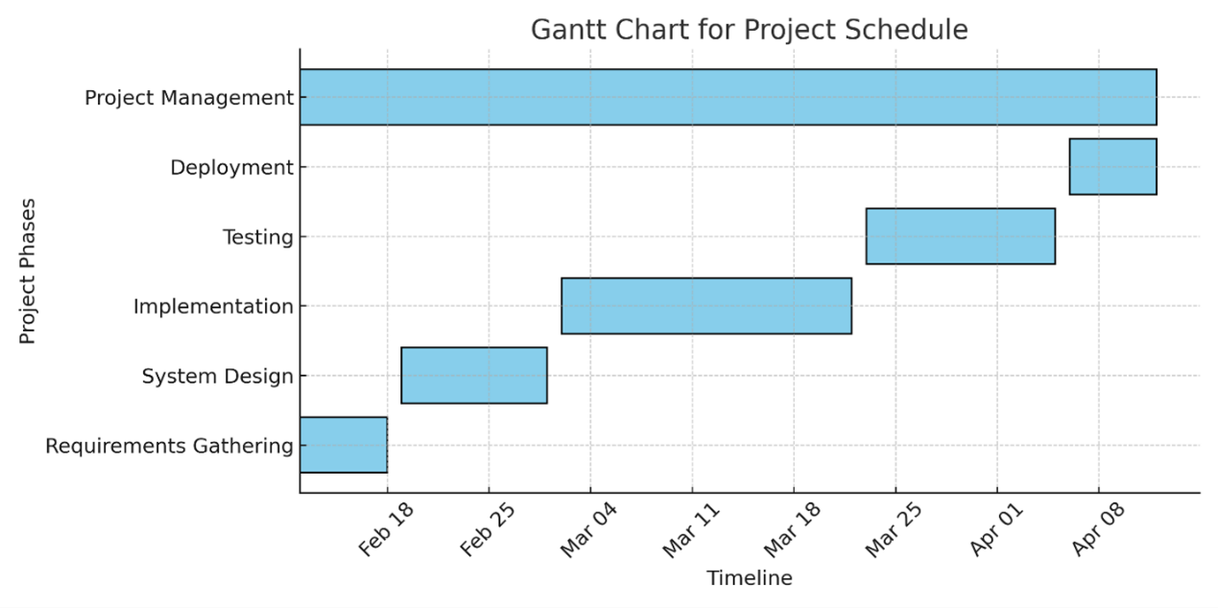

Figure 5 - The Gantt Chart

# REFERENCES

|  |  |
| --- | --- |
| [1] | GeeksforGeeks (2018). *Waterfall Model - Software Engineering*. [online] GeeksforGeeks. Available at: https://www.geeksforgeeks.org/waterfall-model/. [Accessed 11 February 2025]  ‌ |
| [2] | Waseem, A. (2023). *Waterfall Methodology – Ultimate Guide*. [online] Management Library. Available at: https://management.org/waterfall-methodology. [Accessed 11 February 2025]  ‌ |
| [3] | GeeksforGeeks (2023). *Requirements Gathering - Introduction, Processes, Benefits and Tools*. [online] GeeksforGeeks. Available at: https://www.geeksforgeeks.org/requirements-gathering-introduction-processes-benefits-and-tools/. [Accessed 12 February 2025]  ‌ |

# APPENDICES